OVLP Academic Year 2025-26
Duration: March 23 – 27, 2026 |  | Grade: Pre-Nursery |  | Subjects: All
Term III |  |  | Week: 4
 | English | Urdu | Math |  | IT | HCD
Links | class story  Tree:  https://drive.google.com/file/d/1YPejH9GCHm0rIpelgWYzrax3qNHjepIF/view?usp=sharing  The Honest Elephant:  https://drive.google.com/file/d/1lwAwKqlnQvW-hFTRBqN4f_tHvo_02jVv/view?usp=sharing  Letter t.  https://drive.google.com/file/d/15NOkS3jv1T6sxFY__0KZkthQGZNBzWam/view?usp=share_link  Reading Letter t.  https://drive.google.com/file/d/1jQSs85RhtL1jh9qyJCu5804AFVccLoGE/view?usp=sharing | Class story  Murghi or chiriya  https://drive.google.com/file/d/1l1Gdko6TYpm5cb6e8JHlenTX2PK9_s5h/view?usp=sharing  Bhalu ka bacha  https://drive.google.com/file/d/1ncUv2pL3RmwAOLrY5lHQ84rCgscjfDzj/view?usp=sharing  Ont or Saya  https://drive.google.com/file/d/1kickcOMQo0xpV-bJFEhDATb68gkuEENC/view?usp=sharing  harf sheen.  https://drive.google.com/file/d/1pz5Yn2Nzm5JT26a3UG9ShzvhU-8xpCYj/view?usp=share_link  Reading harf sheen.  https://drive.google.com/file/d/1xvU0iYtlBhwBvEch2PTvuiFv2pJ4Hgha/view?usp=sharing | Number 19 .  https://drive.google.com/file/d/1Y6QQYYg1DfzT75rVUK0sBbgw32sVOJEv/view?usp=sharing  Reading Number 19 .  https://drive.google.com/file/d/11WnaoOenKyw91vHl6-O_Qn6Ce38xgF9A/view?usp=sharing |  | Week 4 OVLP Grade Pre-Nursery IT Term 3.mp4 | P.N TIIISRP4
Day 1  C.W | Eid Holiday |  |  |  |  | Holiday
Home work | ___________ |  |  |  |  | -------------
Day 2  C.W | Reading letter t. | 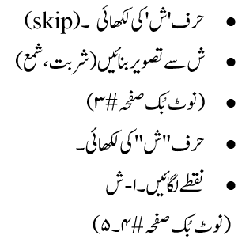 | - Write number “19”.  - Backward counting ( 5 – 0 )  - Note book pg. # 3 |  |  | Pupils will learn about Respecting People/ Fruits
Home work |  | 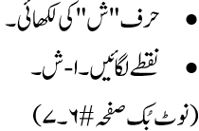 |  |  |  | -------
Day 3 | - Writing “t”.(skip)  - Draw a picture. (tomato or toy)  - Note book pg. # 4  - Writing “t”.  - Circle all “t”.  - Note book pg. # 5 | 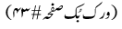 | - Write number “19”.  - Count and match (18, 19, 20)  - Note book pg. # 4 |  |  | Pupils will learn about the food of the week is “Cheese”
Home work |  |  | - Write number “19”.  - Backward counting (5 – 0).  Note book pg. # 5 |  |  | --------
Day 4  C.W | - Write a-t.  - Match the same letters (r- t).  - Note book pg. # 6 | 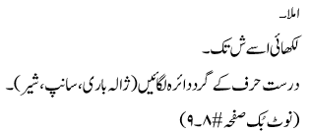 | Workbook pg. # (75-76). |  |  | Pupils will be playing the game Fruit basket  Oral questions and answers  Q 1: On which day do we celebrate Pakistan’s Independence Day? Ans: We celebrate Pakistan’s Independence Day on 14th August.  Q 1: How many Fast do we have in Ramadan? Ans: There are 30 Fast in Ramadan.  Q 1: Tell the names of 5 fruits. Apple, Banana, Orange, Grapes and Watermelon.
Home work |  |  |  |  | -- | ------
Day 5  C.W | - Dictation.  - Write a-t.  - Note book pg. # 7 | حرف ش کی پڑھائی | - Dictation.  - Draw accordingly 18,19.  - Note book pg. # 6 |  |  | The revision of all the previous work done this week is complete.
Home work | Reinforcement sheet  OGA will be taken on Monday. |  |  |  | -- | -------------

